<Contact Name> March 2024
<Business Name>
<Address Line 1>
<Address Line 2>

Aloha,

For over 112 years, everyone in Hawaii has been the beneficiary of The Outdoor Circle’s beautification and advocacy efforts.

- Local communities across the state enjoy neighborhoods, business districts, highways and our view planes free of billboards due to The Outdoor Circle’s continuing vigilance.
- Residents and visitors enjoy and are sustained by The Outdoor Circle’s tree plantings and beautification projects in neighborhoods, along major thoroughfares and in parks.
- Our real estate industry relies on clients who are drawn to our communities for their parks and tree-lined streets, due in large part to The Outdoor Circle efforts.
- Our visitor and tourism industry highlights Hawaii’s natural beauty and cultural resources to attract guests to choose Hawaii as their vacation destination. The Outdoor Circle has played a major role in preserving Hawaii’s rich historical and cultural heritage, fragile natural resources and spectacular scenic view planes.

Since our founding in 1912, The Outdoor Circle has been Hawaii’s long-standing and leading non-profit organization for protecting and enhancing the environment and natural beauty of Hawaii. Through the efforts of generations of our dedicated volunteers, we have pursued our stewardship mission of keeping our Islands clean, green and beautiful.

Hawaii is our shared home, and it is all of our collective duty to protect these beautiful islands for future generations, to ensure that our communities are livable, our families are healthy, and our spirits are nourished by our green environment. We invite you to join us!
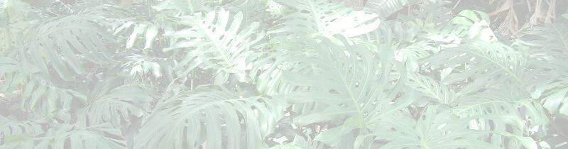
Make a Pledge to Hawaii’s Future
with a Donation to The Outdoor Circle’s
Annual “Keep Hawaii Beautiful” Pledge Drive!

The Outdoor Circle has a proven track record of performance and reliability and holds a prestigious GuideStar Platinum Seal of Transparency indicating outstanding leadership and effectiveness. By working together across our diverse communities, The Outdoor Circle has been responsive to and respectful of those unique community needs and has leveraged our collective strengths to further the establishment of lasting protections in both policy and programs for Hawaii’s environment and people.
Who We Are
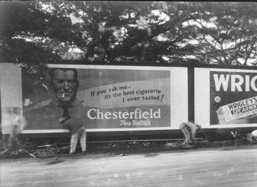
The Outdoor Circle and its Branches from Kauai to Hawai’i Island operate through all-volunteer Boards of Directors consisting of experienced Urban Planners, Landscape Architects, Arborists, Legal and Financial Consultants, Horticulturalists, Green Industry Representatives, Native Species Experts, and Community Members who care deeply about maintaining the beauty of our Island state. We have an experienced office staff consisting of an Executive Director with Certified Association Executive (CAE) credentials, a Programs Manager with extensive background in Environmental Sciences, and an Office Administrator with broad expertise in non-profit operations.
Honolulu Streets @1920 … And Today
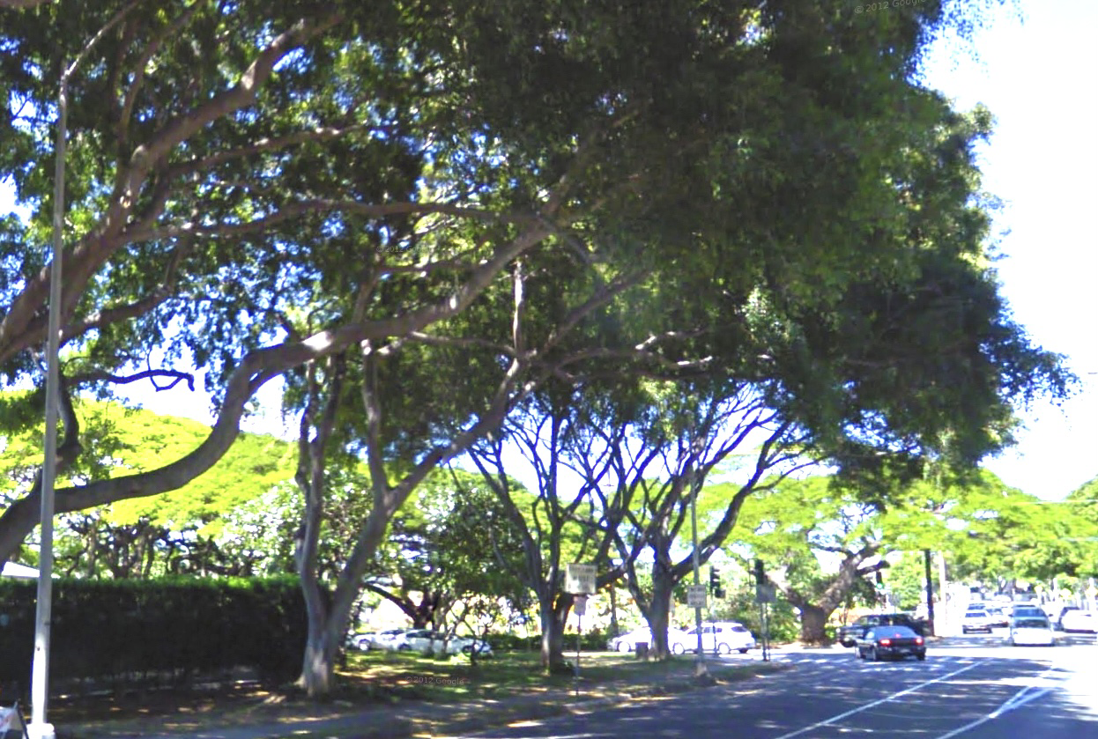
Through our civic engagement, The Outdoor Circle strives not only to enhance our public green-scapes through community-based beautification and tree planting projects, but to educate the public about the value and importance of environmental stewardship.

But our work does not stop there. We continue to protect our landscape and scenic view planes from visual clutter and billboards, maintain green spaces and nature parks, protect wetlands, watersheds and cultural sites, rehabilitate and preserve native forests and ecosystems and strongly advocate for sound public policies ensuring that our Island home is livable and sustainable.

The vision of The Outdoor Circle’s early founders over a century ago has fostered and inspired generations of environmental stewards who have kept this legacy alive and flourishing. We welcome you to join us!

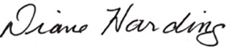
Sincerely,
Winston Welch Diane Harding
The Outdoor Circle Executive Director The Outdoor Circle President
Your support is not just a donation – it’s a commitment to
“Keeping Hawaii Beautiful!”

Mahalo for Investing in Hawaii’s Future!

The Outdoor Circle is a Hawaii-based non-profit 501c3 organization funded primarily through grants and donations, which are fully tax-deductible. You may use the enclosed donation card or donate online at www.outdoorcircle.org/Keep-Hawaii-Beautiful
To learn more about The Outdoor Circle, or to join us in our efforts, visit: www.outdoorcircle.org
For a detailed history of The Outdoor Circle, visit: www.outdoorcircle.org/history-of-toc.html
To learn more about ways to support us, visit: www.outdoorcircle.org/ways-to-give.html.
Why Your Support for The Outdoor Circle Matters to Hawaii
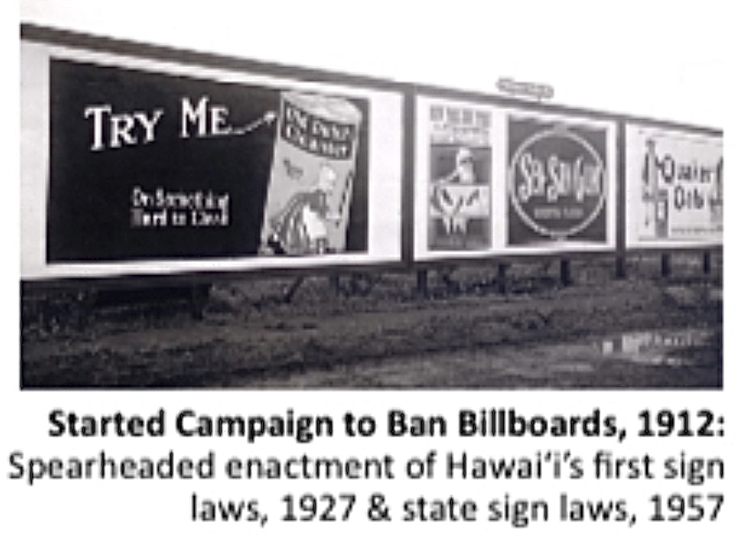
The Outdoor Circle’s history over the last 112 years is filled with well-recognized significant achievements, such as our 1912 campaign to eliminate billboards from the Territory of Hawaii, and subsequently from the State. Hawaii’s billboard free environment is now the envy of the nation. Our tree planting and tree preservation projects started in urban Honolulu in 1912 and have spread throughout communities across the islands, with over one million trees planted to date.

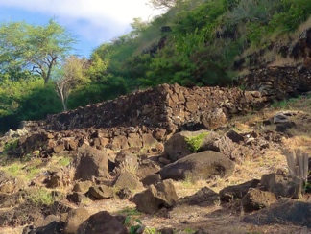
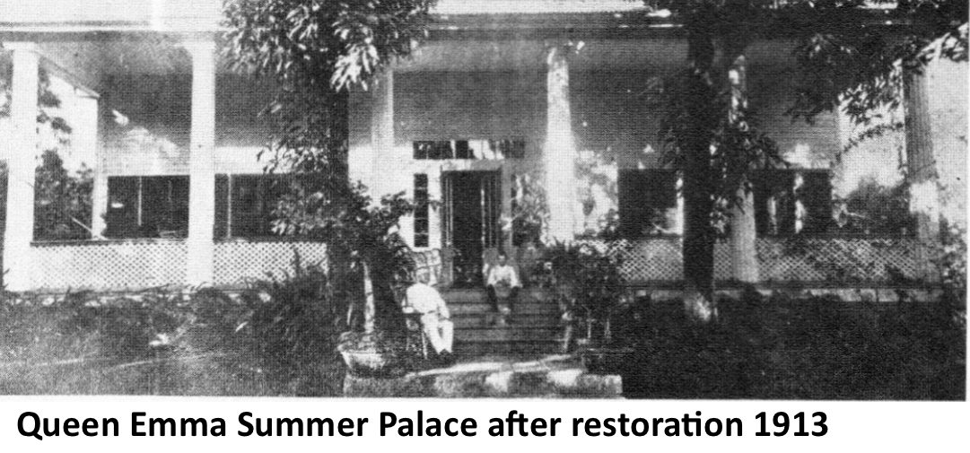
In 1913, The Outdoor Circle collaborated with the “Daughters of Hawaii” to save the deteriorating Queen Emma Summer Palace from demolition to install a baseball park. In 1914 and 1922, we spearheaded replanting the Iolani Palace grounds, and we refurbished the gardens of Washington Place in the 1930s and again in 1963. The Outdoor Circle led the clearing of Ulupo Heiau, in Kailua, Oahu, for archeological inspection in 1951, and restored Pahua Heiau in Hawaii Kai, Oahu in 1984 … thus preserving these valuable cultural and historical resources for the benefit of all of Hawaii.
Pahua Heiau restoration 1984

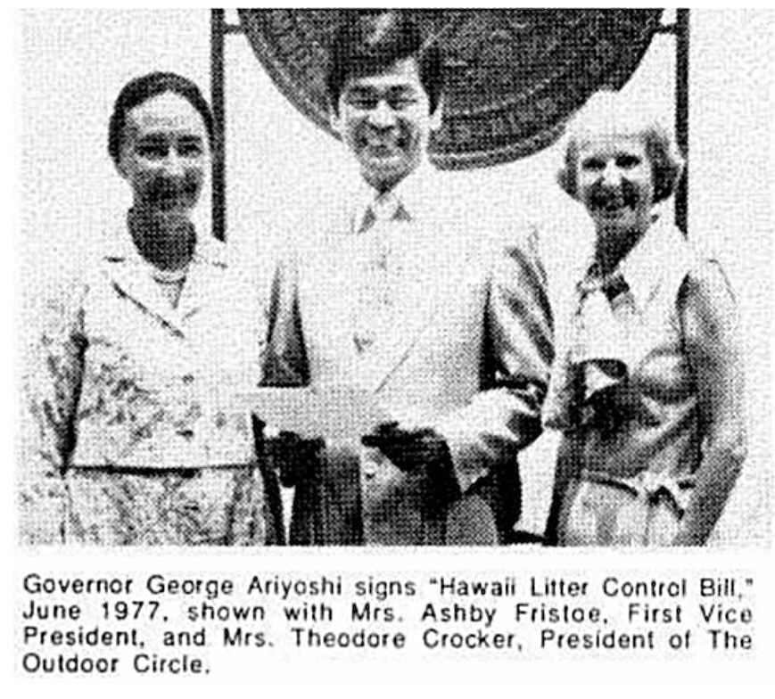
The Outdoor Circle established Oahu’s first recycling plant in 1967, “Cash for Trash”, which led to the 1977 “Hawaii State Litter Control Bill, Act 2”, whose provisions are still in force in the Hawaii Revised Statutes. Through our advocacy, Oahu’s Kualoa Ahupua’a was protected from development and placed on the State Historic Register in 1974, and the Diamond Head State Monument and Crater, one of the most visited attractions in Hawaii, was dedicated and opened to the public by The Outdoor Circle in 1978.

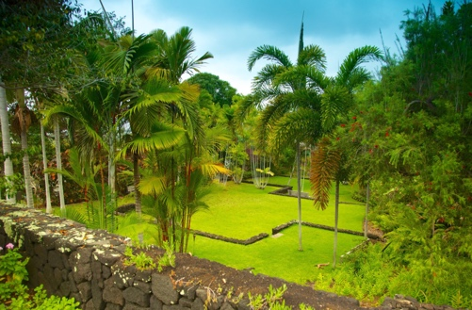
The Outdoor Circle founded the Hawaii Nature Center in Makiki, Oahu in 1981, the Sadie Seymour Botanical Gardens in Kona in 1986, the Ulu La’au Nature Park in Waimea, Hawaii Island in 1999, and helped establish the Waikoloa Dry Forest Initiative in 2014 … thus cultivating and fostering the public’s appreciation for and stewardship of Hawaii’s unique natural environment.
Sadie Seymour Botanical Gardens, Kona 1986

Through The Outdoor Circle’s advocacy efforts in 2004, we spearheaded Hawaii State tax incentives to protect our Heritage and Exceptional Trees and, in 2014, were instrumental in establishing the Hawaii State Environmental Court, the second in the nation.

For over a century, all of Hawai‘i has been the beneficiary of the beautification, advocacy and environmental work of The Outdoor Circle.

Let’s Keep Hawaii Beautiful!”
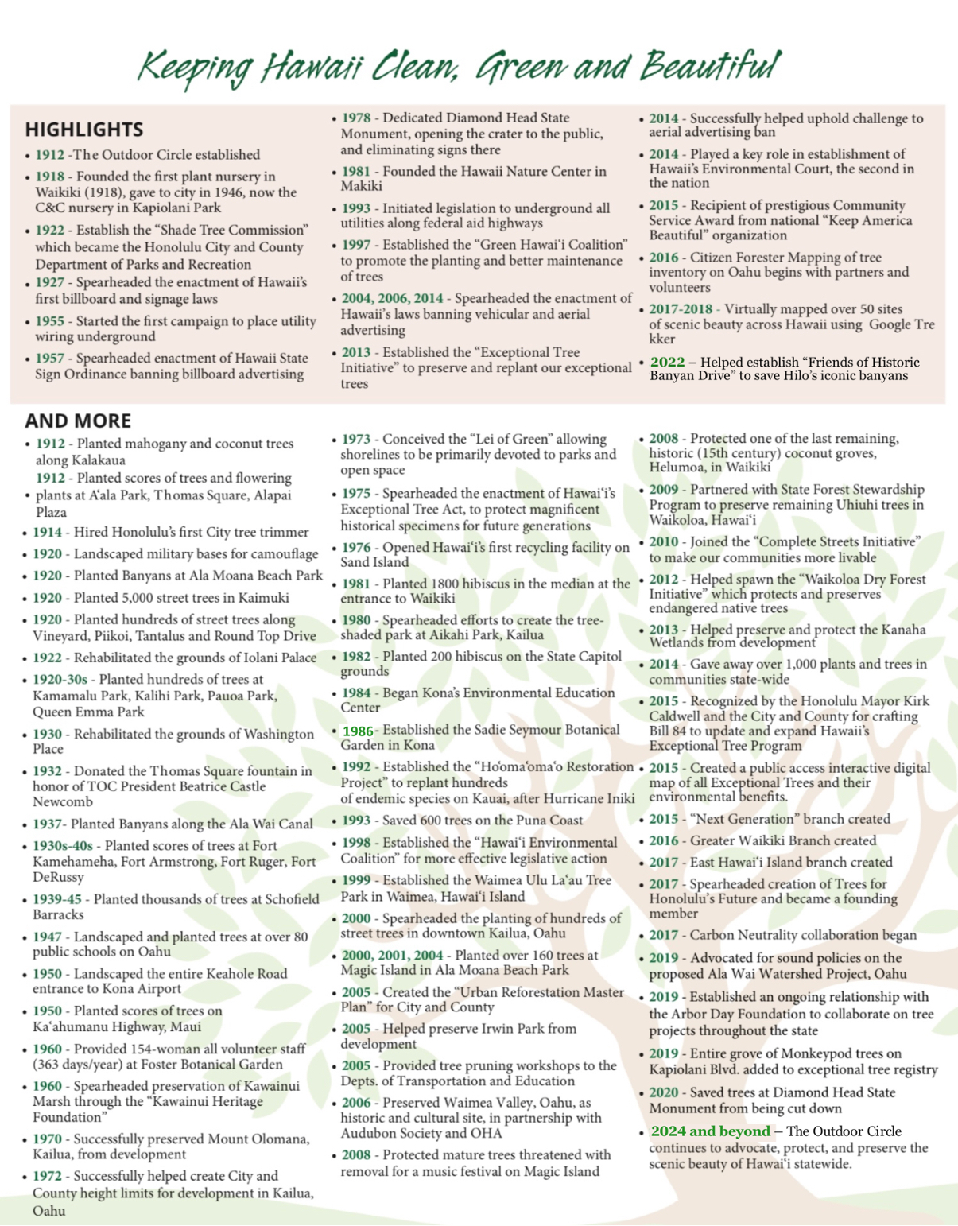
Our efforts statewide have been in collaboration with and funded through City, County and State entities, foundations, private corporations and businesses, private donations, and grants. Major financial supporters have included State of Hawaii, County of Hawaii, Honolulu City and County, Hawaiian Electric Company, Inc., Kaneohe Ranch, Alexander & Baldwin, Inc., General Growth Properties, Enterprise Car Rental, International Paper, Fed Ex, Hardware Hawaii, BOSH Inc, Adventist Health Castle, Prisanlee Fund, Poha Fund, Richard and Esther Wong Fund, Women’s Fund of Hawaii, Kamehameha Schools, Harold K.L. Castle Foundation, Armstrong Foundation, Hawaii Community Foundation, Arbor Day Foundation, MacNaughton Group Foundation, Padosi Foundation, Atherton Family Foundation, Zadoc and Lawrence Brown Foundation, LGA Family Foundation, Domestic Violence Action Center.

Sample Pledge Card to enclose.
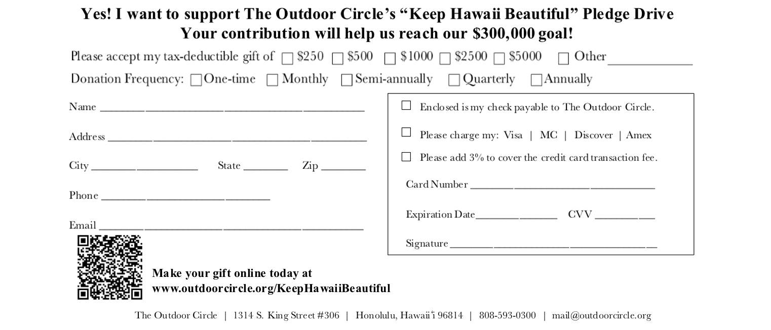

Your contribution will help us maintain our legacy and reach our Million Dollar goal!

Please accept my tax-deductible gift of $_____________

